**Industrial Internship Report on**

**”File Manager By Using Python”**

**Prepared by**

**VIRUPAKSHI**

|  |
| --- |
| *Executive Summary* |
| This report provides details of the Industrial Internship provided by upskill Campus and The IoT Academy in collaboration with Industrial Partner UniConverge Technologies Pvt Ltd (UCT).  This internship was focused on a project/problem statement provided by UCT. We had to finish the project including the report in 6 weeks’ time.  My project was “File manager”  This internship gave me a very good opportunity to get exposure to Industrial problems and design/implement solution for that. It was an overall great experience to have this internship. |

Internship Duration : 1st June 2023 – 15th July 2023

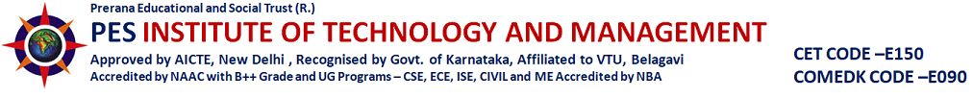

**TABLE OF CONTENTS**

1 Preface 3

2 Introduction 4

2.1 About UniConverge Technologies Pvt Ltd 4

2.2 About upskill Campus 8

2.3 Objective 9

2.4 Reference 10

2.5 Glossary 10

3 Problem Statement 11

4 Existing and Proposed solution 12

5 Proposed Design/ Model 13

5.1 High Level Diagram (if applicable) 13

5.2 Low Level Diagram (if applicable) 14

5.3 Interfaces (if applicable) 15

6 Performance Test 16

6.1 Test Plan/ Test Cases 16

6.2 Test Procedure 21

6.3 Performance Outcome 21

7 My learnings 22

8 Future work scope 23

# Preface

These six weeks are more amazing to me, Because I am started my First Internship in my own interested domain. Started learning more things in Python. Week by week my eagerness towards Python starts linearly increasing. It’s a great opportunity to me.

There is need of such Skills in present industry to fulfill the industrial demand in IT Sector. So I am looking for these like opportunities in Python, Data Science, AIML etc…

I am prepared a project called “File Manager/ File explorer”. It offers the user to Create a new Folder, Rename the existing, Convert Image file to PDF file etc…

I am very thankful to USC and UCT, for giving us such opportunity to learn more in our Interesting Domains at free of cost. And all the team for guiding us in well planned way and helped to complete our 06 week Internship.



I Learnt many things in this 06 weeks Internship Journey. Really, the whole team in the internship was supportive. Connected with Future software professionals (friends, teammates) in ‘LinkdIn”. And discussed each other regarding our Projects. Shared our opinions. We all are from different parts of the country get connected now. We discussed each other with Innovative Ideas, Innovative Thinking and so on.

# Introduction

## About UniConverge Technologies Pvt Ltd

A company established in 2013 and working in Digital Transformation domain and providing Industrial solutions with prime focus on sustainability and RoI.

For developing its products and solutions it is leveraging various**Cutting Edge Technologies e.g. Internet of Things (IoT), Cyber Security, Cloud computing (AWS, Azure), Machine Learning, Communication Technologies (4G/5G/LoRaWAN), Java Full Stack, Python, Front end**etc.



1. UCT IoT Platform **(****)**

**UCT Insight** is an IOT platform designed for quick deployment of IOT applications on the same time providing valuable “insight” for your process/business. It has been built in Java for backend and ReactJS for Front end. It has support for MySQL and various NoSql Databases.

* It enables device connectivity via industry standard IoT protocols - MQTT, CoAP, HTTP, Modbus TCP, OPC UA
* It supports both cloud and on-premises deployments.

It has features to  
• Build Your own dashboard  
• Analytics and Reporting  
• Alert and Notification  
• Integration with third party application(Power BI, SAP, ERP)  
• Rule Engine

 

1. **Smart Factory Platform (****)**

Factory watch is a platform for smart factory needs.

It provides Users/ Factory

* with a scalable solution for their Production and asset monitoring
* OEE and predictive maintenance solution scaling up to digital twin for your assets.
* to unleased the true potential of the data that their machines are generating and helps to identify the KPIs and also improve them.
* A modular architecture that allows users to choose the service that they what to start and then can scale to more complex solutions as per their demands.

Its unique SaaS model helps users to save time, cost and money.

 

1.  based Solution

UCT is one of the early adopters of LoRAWAN teschnology and providing solution in Agritech, Smart cities, Industrial Monitoring, Smart Street Light, Smart Water/ Gas/ Electricity metering solutions etc.

1. Predictive Maintenance

UCT is providing Industrial Machine health monitoring and Predictive maintenance solution leveraging Embedded system, Industrial IoT and Machine Learning Technologies by finding Remaining useful life time of various Machines used in production process.



## About upskill Campus (USC)

upskill Campus along with The IoT Academy and in association with Uniconverge technologies has facilitated the smooth execution of the complete internship process.

USC is a career development platform that delivers **personalized executive coaching** in a more affordable, scalable and measurable way.



Seeing need of upskilling in self paced manner along-with additional support services e.g. Internship, projects, interaction with Industry experts, Career growth Services

<https://www.upskillcampus.com/>

upSkill Campus aiming to upskill 1 million learners in next 5 year



## The IoT Academy

The IoT academy is EdTech Division of UCT that is running long executive certification programs in collaboration with EICT Academy, IITK, IITR and IITG in multiple domains.

## Objectives of this Internship program

The objective for this internship program was to

 ☛ get practical experience of working in the industry.

 ☛ to solve real world problems.

 ☛ to have improved job prospects.

 ☛ to have Improved understanding of our field and its applications.

 ☛ to have Personal growth like better communication and problem solving.

## Reference

[1] Python Crash Course By Eric Matthes

[2] Python Programming By Reema Thareja

## Glossary

|  |  |
| --- | --- |
| Terms | Acronym |
| OOP | Object Oriented Programming |
| PIP | Package Installer For Python |
| GUI | Graphical User Interfere |
| UCT | Unicoverage Technologies Ltd |
| USC | Upskill Campus |

# Problem Statement

In the assigned problem statement

Description: The file organizer is a Python project that helps users organize their files in a directory. It scans a specified directory, categorizes files based on their type (e.g., images, documents, videos), and moves them into respective folders.

Scope: The scope of this project involves designing a user interface to specify the directory to organize, implementing functions to identify file types and create folders, and developing a file-moving algorithm to organize files into the appropriate folders.

# Existing and Proposed solution

File Manager/ File Explorer are such application where the user can store all the Files in it. The file may be PDF, IMAGE, DOCX, TXT or other. In such applications user have limited operations to perform like creating folder, Renaming the file, Copy and Paste. Folders help you keep your files organized and separate. If you have no folders on your computer, your documents, programs and operating system files would all be located in the same place.

Here, I am added some more operations to perform. Like Converting Image to PDF. Better Resolution. Through the PDF file, you can have a better resolution of your images. This means, if you want the quality to not be compromised, PDF file it is then.

## Code submission (Github link) [Git Hub Link](https://github.com/V-Code-S/Upskill-Campus-Virupakshi)

## Report submission (Github link) : https://github.com/V-Code-S/Upskill-Campus-Virupakshi

# Proposed Design/ Model

File explorer / manager is available on every laptop or computer we use. It helps to access files with the help of a graphical user interface. In this project, we will be creating a file explorer. Let’s start developing this Python File Manager project..

## High Level Diagram (if applicable)

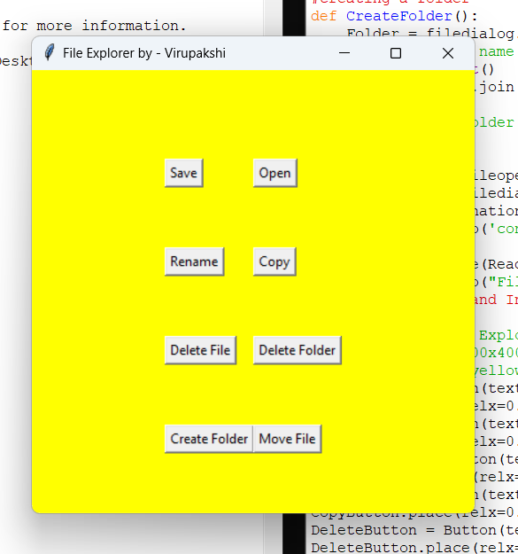

Figure 1: HIGH LEVEL DIAGRAM OF THE SYSTEM

## Low Level Diagram (if applicable)

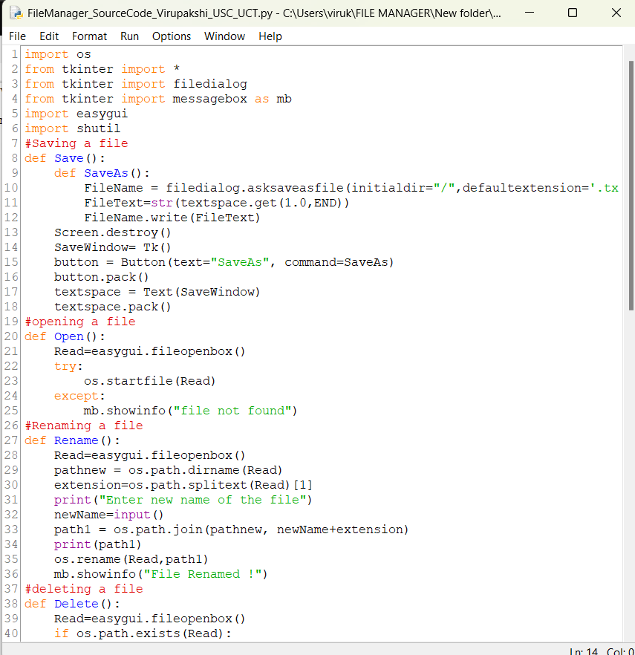

## Interfaces (if applicable)

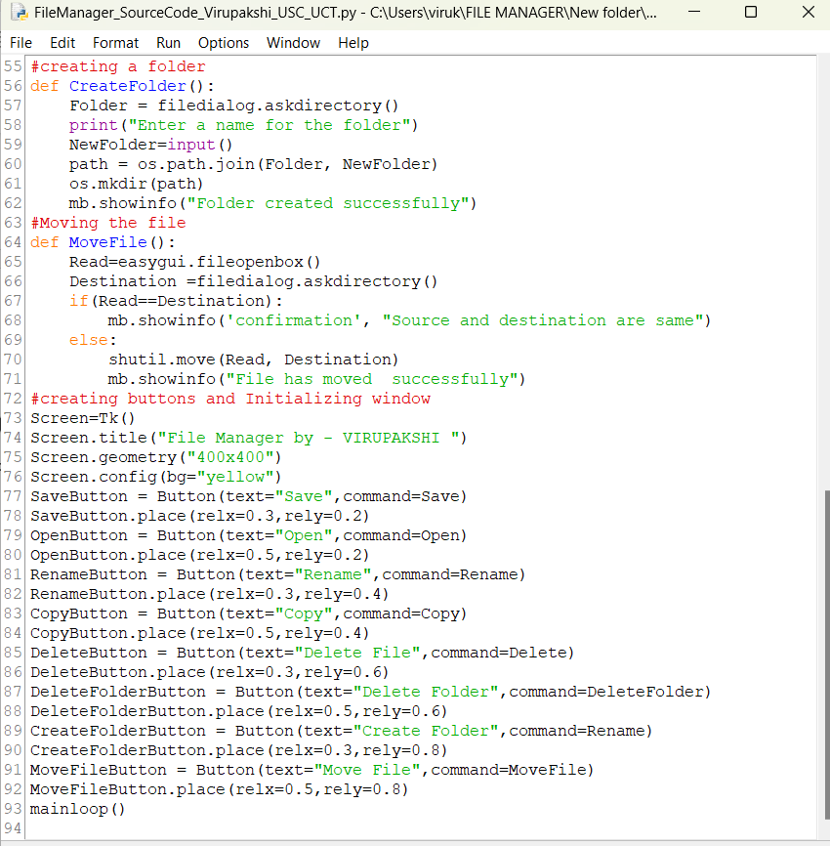

# Performance Test

In this project, we will develop a file explorer that will help us to save, open, rename, delete and move files and will also help in creating and deleting the folder.

Here we need to first find the constraints.

How those constraints were taken care in your design?

What were test results around those constraints?

Constraints can be e.g. memory, MIPS (speed, operations per second), accuracy, durability, power consumption etc.

In case you could not test them, but still you should mention how identified constraints can impact your design, and what are recommendations to handle them.

## Test Plan/ Test Cases

The objective of this Python File Manager Project is to create our own File Explorer. Install tkinter and easygui to start developing the project.

Project Prerequisites

Basic knowledge of tkinter and easygui is required to develop this project. Furthermore, knowledge of functions is also required.

Project File Structure

Installing tkinter and easygui  
2. Importing libraries  
3. Save the File  
4. Open the File  
5. Renaming the file  
6. Deleting a file  
7. Copying a file  
8. Deleting a folder  
9. Creating a folder  
10. Moving a folder  
11. Initializing window and creating button

#### Installing tkinter and easygui:

To start developing the project, installation of these two modules is required. To install these modules write the following command on command prompt or terminal window.

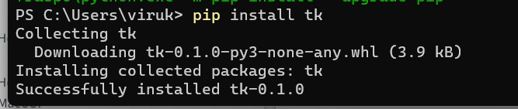

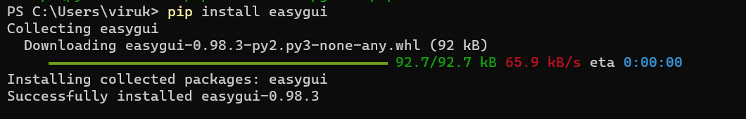

#### Importing libraries :

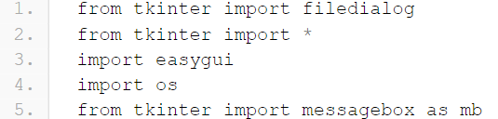

**Code Explanation:**

**a. tkinter:** It is the most used Graphical User Interface package in python.  
**b. filedialog:** While working with files, filedialog provides a set of dialogs.  
**c. easygui:** It is the most easy Graphical User Interface module. This module is not event driven.  
**d. os:**When different files are processed from different locations.  
**e. messagebox:** Message boxes are displayed with the help of messagebox.

#### Save the File :

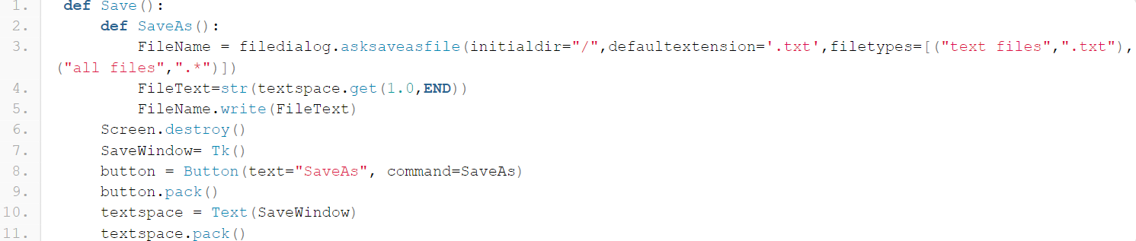

**Code Explanation:**

Save function displays a text area where we can enter the text that is to be saved. SaveAs function saves the file.  
**a. destroy:** It is used to destroy a widget.  
**b. Tk():** We create Tk() to initialise the tkinter module.  
**c. pack():** It organizes widgets in blocks. After this they are placed in the parent widget.  
**d. filetypes:** It contains the type of the file.

#### Open the File:

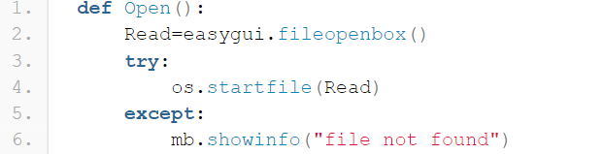

**Code Explanation:**

**a. fileopenbox():**It is used to display the files. Only those files are displayed whose path matches the default file path.  
**b. startfile():** It opens the file.  
**c. showinfo():** It is used to display the information in the form of a pop up.

#### Renaming the file:

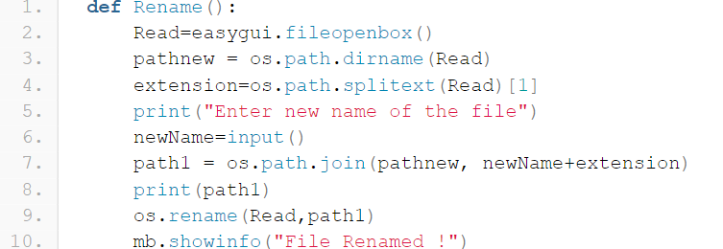

**Code Explanation:**

**a. splittext():** This widget splits the path into ext and pair root.  
**b. showinfo():** It displays the text on the screen.  
**c. join():** It joins two different texts into one string.

#### Deleting a file:

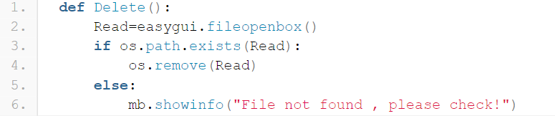

**Code Explanation:**  
**a. exists():** It checks whether the path mentioned exists or not.  
**b. remove():** The given object is removed from the list with this widget.

#### Creating a folder:

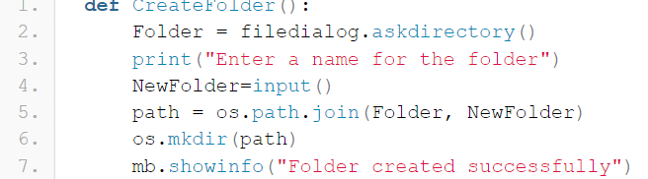

**Code Explanation:**

**a. input():** It takes input from the user.  
**b. mkdir():** New directory with a new path is created with this widget.

#### Initializing window and creating buttons:

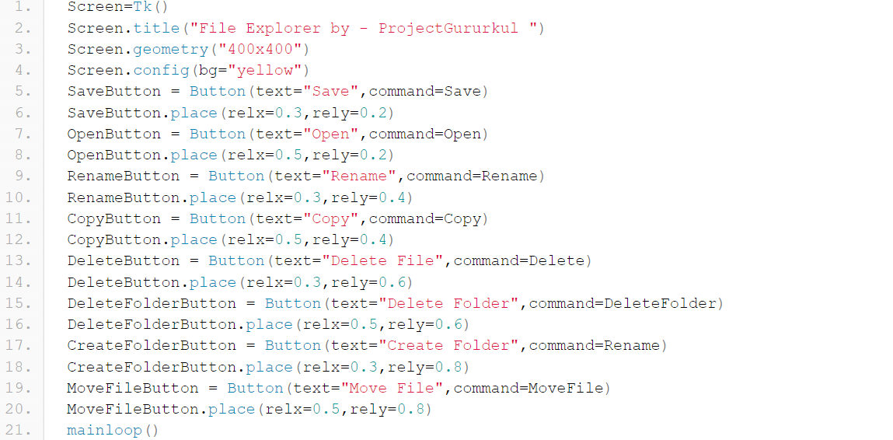

**Code Explanation:**

**a. title()**: It sets the title of the main window.  
**b.geometry()**: The dimensions of the window are set with this widget.  
**c. config():** It changes the property of the widget.  
**d. Button()**: It adds the button on screen.  
**e. place()**: It places the widget in the specific position of the screen.

## Test Procedure

The File Manager / File explorer Project is successfully done, Now we can test Whether it is working In a correct way or not.

Run the code and You will see the Pop-Up window like in the Outcome. You try to rename, Create, Open and Delete operations.

## Performance Outcome



Summary

We have successfully developed python file explorer / manager project with basic tkinter libraries.

# My learnings

We have successfully developed python file explorer / manager project with basic tkinter libraries. It is a wonderful Learning Journey. It helps me more for developing my career.

I develop skill competencies specific to a profession. To expand oral and written communication skills. cultures and to work effectively within diverse environments. To acquire additional interpersonal communication and interaction skills.

Internships allow you to gain experience by watching, learning and participating in the work. This experience can help you land a permanent position, perhaps even at the same company. Networking is one of the primary benefits of internships.

I Developed intrapersonal and interaction skills, By interacting and communicating with others, who were different parts of our country and working on another project.

I am worked on the Project of “File Manager or File Explorer”. After completing the project, I developed more confidence in myself.

# Future work scope

I am a Computer and Science Engineering Student, I have more passion on Python. It is the my favorite Programming Language. Because of its great features. Due to time limitation, We worked here less. But we learnt here more to build our careers. This Industrial Summer Internship given more ideas to work on our interested domains.

Every week it is Unique. It is a great opportunity to show our work on our passion. I will move on my passion. In future Undoubtedly, it offers the most promising career, and this demand for Python developers is growing every time. There is a reason why this high-position programming language is so necessary. Python will remain in the leading position among the other coding languages.